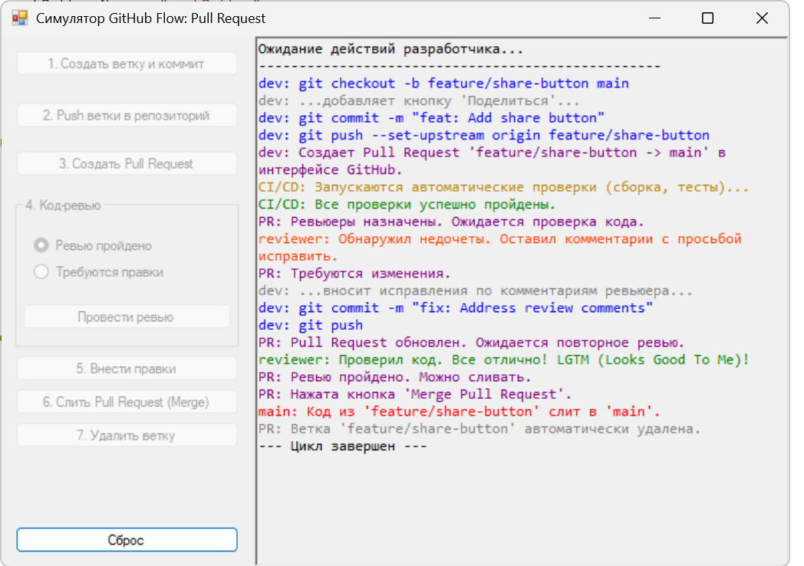

Код using System;

using System.Drawing;

using System.Windows.Forms;

namespace GitHubFlowSimulator

{

public partial class Form1 : Form

{

public Form1()

{

InitializeComponent();

}

private void Form1_Load(object sender, EventArgs e)

{

ResetState();

}

private void createBranchButton_Click(object sender, EventArgs e)

{

LogAction("dev: git checkout -b feature/share-button main", Color.Blue);

LogAction("dev: ...добавляет кнопку 'Поделиться'...", Color.Gray);

LogAction("dev: git commit -m \"feat: Add share button\"", Color.Blue);

UpdateUIState(nextStep: "push");

}

private void pushButton_Click(object sender, EventArgs e)

{

LogAction("dev: git push --set-upstream origin feature/share-button", Color.Blue);

UpdateUIState(nextStep: "create_pr");

}

private void createPRButton_Click(object sender, EventArgs e)

{

LogAction("dev: Создает Pull Request 'feature/share-button -> main' в интерфейсе GitHub.", Color.Purple);

LogAction("CI/CD: Запускаются автоматические проверки (сборка, тесты)...", Color.DarkGoldenrod);

LogAction("CI/CD: Все проверки успешно пройдены.", Color.Green);

LogAction("PR: Ревьюеры назначены. Ожидается проверка кода.", Color.Purple);

UpdateUIState(nextStep: "review");

}

private void submitReviewButton_Click(object sender, EventArgs e)

{

if (reviewApprovedRadio.Checked)

{

LogAction("reviewer: Проверил код. Все отлично! LGTM (Looks Good To Me)!", Color.Green);

LogAction("PR: Ревью пройдено. Можно сливать.", Color.Purple);

UpdateUIState(nextStep: "merge");

}

else

{

LogAction("reviewer: Обнаружил недочеты. Оставил комментарии с просьбой исправить.", Color.OrangeRed);

LogAction("PR: Требуются изменения.", Color.Purple);

UpdateUIState(nextStep: "fix_code");

}

}

private void fixCodeButton_Click(object sender, EventArgs e)

{

LogAction("dev: ...вносит исправления по комментариям ревьюера...", Color.Gray);

LogAction("dev: git commit -m \"fix: Address review comments\"", Color.Blue);

LogAction("dev: git push", Color.Blue);

LogAction("PR: Pull Request обновлен. Ожидается повторное ревью.", Color.Purple);

UpdateUIState(nextStep: "review");

}

private void mergePRButton_Click(object sender, EventArgs e)

{

LogAction("PR: Нажата кнопка 'Merge Pull Request'.", Color.Purple);

LogAction("main: Код из 'feature/share-button' слит в 'main'.", Color.Red);

UpdateUIState(nextStep: "delete_branch");

}

private void deleteBranchButton_Click(object sender, EventArgs e)

{

LogAction("PR: Ветка 'feature/share-button' автоматически удалена.", Color.Gray);

LogAction("--- Цикл завершен ---", Color.Black);

UpdateUIState(nextStep: "end");

}

private void resetButton_Click(object sender, EventArgs e)

{

ResetState();

}

/// <summary>

/// </summary>

private void ResetState()

{

logTextBox.Clear();

LogAction("Ожидание действий разработчика...", Color.Black);

logTextBox.AppendText("--------------------------------------------------\n");

UpdateUIState(nextStep: "start");

}

/// <summary>

/// </summary>

private void UpdateUIState(string nextStep)

{

createBranchButton.Enabled = false;

pushButton.Enabled = false;

createPRButton.Enabled = false;

reviewGroupBox.Enabled = false;

fixCodeButton.Enabled = false;

mergePRButton.Enabled = false;

deleteBranchButton.Enabled = false;

switch (nextStep)

{

case "start":

createBranchButton.Enabled = true;

break;

case "push":

pushButton.Enabled = true;

break;

case "create_pr":

createPRButton.Enabled = true;

break;

case "review":

reviewGroupBox.Enabled = true;

break;

case "fix_code":

fixCodeButton.Enabled = true;

break;

case "merge":

mergePRButton.Enabled = true;

break;

case "delete_branch":

deleteBranchButton.Enabled = true;

break;

case "end":

break;

}

}

/// <summary>

/// </summary>

private void LogAction(string message, Color color)

{

logTextBox.SelectionStart = logTextBox.TextLength;

logTextBox.SelectionLength = 0;

logTextBox.SelectionColor = color;

logTextBox.AppendText(message + Environment.NewLine);

logTextBox.SelectionColor = logTextBox.ForeColor;

logTextBox.ScrollToCaret();

}

#region Windows Form Designer generated code

private System.ComponentModel.IContainer components = null;

protected override void Dispose(bool disposing)

{

if (disposing && (components != null))

{

components.Dispose();

}

base.Dispose(disposing);

}

private void InitializeComponent()

{

this.logTextBox = new System.Windows.Forms.RichTextBox();

this.buttonsPanel = new System.Windows.Forms.Panel();

this.resetButton = new System.Windows.Forms.Button();

this.deleteBranchButton = new System.Windows.Forms.Button();

this.mergePRButton = new System.Windows.Forms.Button();

this.fixCodeButton = new System.Windows.Forms.Button();

this.reviewGroupBox = new System.Windows.Forms.GroupBox();

this.submitReviewButton = new System.Windows.Forms.Button();

this.reviewChangesRadio = new System.Windows.Forms.RadioButton();

this.reviewApprovedRadio = new System.Windows.Forms.RadioButton();

this.createPRButton = new System.Windows.Forms.Button();

this.pushButton = new System.Windows.Forms.Button();

this.createBranchButton = new System.Windows.Forms.Button();

this.buttonsPanel.SuspendLayout();

this.reviewGroupBox.SuspendLayout();

this.SuspendLayout();

//

// logTextBox

//

this.logTextBox.Dock = System.Windows.Forms.DockStyle.Fill;

this.logTextBox.Font = new System.Drawing.Font("Consolas", 9.75F, System.Drawing.FontStyle.Regular, System.Drawing.GraphicsUnit.Point, ((byte)(204)));

this.logTextBox.Location = new System.Drawing.Point(220, 0);

this.logTextBox.Name = "logTextBox";

this.logTextBox.ReadOnly = true;

this.logTextBox.Size = new System.Drawing.Size(464, 461);

this.logTextBox.TabIndex = 0;

this.logTextBox.Text = "";

//

// buttonsPanel

//

this.buttonsPanel.Controls.Add(this.resetButton);

this.buttonsPanel.Controls.Add(this.deleteBranchButton);

this.buttonsPanel.Controls.Add(this.mergePRButton);

this.buttonsPanel.Controls.Add(this.fixCodeButton);

this.buttonsPanel.Controls.Add(this.reviewGroupBox);

this.buttonsPanel.Controls.Add(this.createPRButton);

this.buttonsPanel.Controls.Add(this.pushButton);

this.buttonsPanel.Controls.Add(this.createBranchButton);

this.buttonsPanel.Dock = System.Windows.Forms.DockStyle.Left;

this.buttonsPanel.Location = new System.Drawing.Point(0, 0);

this.buttonsPanel.Name = "buttonsPanel";

this.buttonsPanel.Size = new System.Drawing.Size(220, 461);

this.buttonsPanel.TabIndex = 1;

//

// resetButton

//

this.resetButton.Location = new System.Drawing.Point(12, 426);

this.resetButton.Name = "resetButton";

this.resetButton.Size = new System.Drawing.Size(194, 23);

this.resetButton.TabIndex = 7;

this.resetButton.Text = "Сброс";

this.resetButton.UseVisualStyleBackColor = true;

this.resetButton.Click += new System.EventHandler(this.resetButton_Click);

//

// deleteBranchButton

//

this.deleteBranchButton.Location = new System.Drawing.Point(12, 335);

this.deleteBranchButton.Name = "deleteBranchButton";

this.deleteBranchButton.Size = new System.Drawing.Size(194, 23);

this.deleteBranchButton.TabIndex = 6;

this.deleteBranchButton.Text = "7. Удалить ветку";

this.deleteBranchButton.UseVisualStyleBackColor = true;

this.deleteBranchButton.Click += new System.EventHandler(this.deleteBranchButton_Click);

//

// mergePRButton

//

this.mergePRButton.Location = new System.Drawing.Point(12, 306);

this.mergePRButton.Name = "mergePRButton";

this.mergePRButton.Size = new System.Drawing.Size(194, 23);

this.mergePRButton.TabIndex = 5;

this.mergePRButton.Text = "6. Слить Pull Request (Merge)";

this.mergePRButton.UseVisualStyleBackColor = true;

this.mergePRButton.Click += new System.EventHandler(this.mergePRButton_Click);

//

// fixCodeButton

//

this.fixCodeButton.Location = new System.Drawing.Point(12, 277);

this.fixCodeButton.Name = "fixCodeButton";

this.fixCodeButton.Size = new System.Drawing.Size(194, 23);

this.fixCodeButton.TabIndex = 4;

this.fixCodeButton.Text = "5. Внести правки";

this.fixCodeButton.UseVisualStyleBackColor = true;

this.fixCodeButton.Click += new System.EventHandler(this.fixCodeButton_Click);

//

// reviewGroupBox

//

this.reviewGroupBox.Controls.Add(this.submitReviewButton);

this.reviewGroupBox.Controls.Add(this.reviewChangesRadio);

this.reviewGroupBox.Controls.Add(this.reviewApprovedRadio);

this.reviewGroupBox.Location = new System.Drawing.Point(12, 140);

this.reviewGroupBox.Name = "reviewGroupBox";

this.reviewGroupBox.Size = new System.Drawing.Size(194, 131);

this.reviewGroupBox.TabIndex = 3;

this.reviewGroupBox.TabStop = false;

this.reviewGroupBox.Text = "4. Код-ревью";

//

// submitReviewButton

//

this.submitReviewButton.Location = new System.Drawing.Point(6, 92);

this.submitReviewButton.Name = "submitReviewButton";

this.submitReviewButton.Size = new System.Drawing.Size(182, 23);

this.submitReviewButton.TabIndex = 2;

this.submitReviewButton.Text = "Провести ревью";

this.submitReviewButton.UseVisualStyleBackColor = true;

this.submitReviewButton.Click += new System.EventHandler(this.submitReviewButton_Click);

//

//

this.reviewChangesRadio.AutoSize = true;

this.reviewChangesRadio.Location = new System.Drawing.Point(16, 56);

this.reviewChangesRadio.Name = "reviewChangesRadio";

this.reviewChangesRadio.Size = new System.Drawing.Size(115, 17);

this.reviewChangesRadio.TabIndex = 1;

this.reviewChangesRadio.Text = "Требуются правки";

this.reviewChangesRadio.UseVisualStyleBackColor = true;

//

//

this.reviewApprovedRadio.AutoSize = true;

this.reviewApprovedRadio.Checked = true;

this.reviewApprovedRadio.Location = new System.Drawing.Point(16, 33);

this.reviewApprovedRadio.Name = "reviewApprovedRadio";

this.reviewApprovedRadio.Size = new System.Drawing.Size(104, 17);

this.reviewApprovedRadio.TabIndex = 0;

this.reviewApprovedRadio.TabStop = true;

this.reviewApprovedRadio.Text = "Ревью пройдено";

this.reviewApprovedRadio.UseVisualStyleBackColor = true;

//

//

this.createPRButton.Location = new System.Drawing.Point(12, 99);

this.createPRButton.Name = "createPRButton";

this.createPRButton.Size = new System.Drawing.Size(194, 23);

this.createPRButton.TabIndex = 2;

this.createPRButton.Text = "3. Создать Pull Request";

this.createPRButton.UseVisualStyleBackColor = true;

this.createPRButton.Click += new System.EventHandler(this.createPRButton_Click);

//

//

this.pushButton.Location = new System.Drawing.Point(12, 57);

this.pushButton.Name = "pushButton";

this.pushButton.Size = new System.Drawing.Size(194, 23);

this.pushButton.TabIndex = 1;

this.pushButton.Text = "2. Push ветки в репозиторий";

this.pushButton.UseVisualStyleBackColor = true;

this.pushButton.Click += new System.EventHandler(this.pushButton_Click);

//

//

this.createBranchButton.Location = new System.Drawing.Point(12, 12);

this.createBranchButton.Name = "createBranchButton";

this.createBranchButton.Size = new System.Drawing.Size(194, 23);

this.createBranchButton.TabIndex = 0;

this.createBranchButton.Text = "1. Создать ветку и коммит";

this.createBranchButton.UseVisualStyleBackColor = true;

this.createBranchButton.Click += new System.EventHandler(this.createBranchButton_Click);

//

//

this.AutoScaleDimensions = new System.Drawing.SizeF(6F, 13F);

this.AutoScaleMode = System.Windows.Forms.AutoScaleMode.Font;

this.ClientSize = new System.Drawing.Size(684, 461);

this.Controls.Add(this.logTextBox);

this.Controls.Add(this.buttonsPanel);

this.FormBorderStyle = System.Windows.Forms.FormBorderStyle.FixedSingle;

this.Name = "Form1";

this.StartPosition = System.Windows.Forms.FormStartPosition.CenterScreen;

this.Text = "Симулятор GitHub Flow: Pull Request";

this.Load += new System.EventHandler(this.Form1_Load);

this.buttonsPanel.ResumeLayout(false);

this.reviewGroupBox.ResumeLayout(false);

this.reviewGroupBox.PerformLayout();

this.ResumeLayout(false);

}

#endregion

private System.Windows.Forms.RichTextBox logTextBox;

private System.Windows.Forms.Panel buttonsPanel;

private System.Windows.Forms.Button createBranchButton;

private System.Windows.Forms.Button pushButton;

private System.Windows.Forms.Button createPRButton;

private System.Windows.Forms.GroupBox reviewGroupBox;

private System.Windows.Forms.Button submitReviewButton;

private System.Windows.Forms.RadioButton reviewChangesRadio;

private System.Windows.Forms.RadioButton reviewApprovedRadio;

private System.Windows.Forms.Button fixCodeButton;

private System.Windows.Forms.Button mergePRButton;

private System.Windows.Forms.Button deleteBranchButton;

private System.Windows.Forms.Button resetButton;

}

}